Task 1: Delete the last 3 lines of a file

Step 1: Create a working directory
Open your Linux terminal or connect to your EC2 instance.
mkdir -p ~/devops-cloud-documents
cd ~/devops-cloud-documents

Step 2: Create a sample file
nano sample.txt
Add these lines:
Line 1
Line 2
Line 3
Line 4
Line 5
Line 6
Save using Ctrl+O, press Enter, then Ctrl+X.

Step 3: Create the Bash script
nano delete_last_3_lines.sh
Paste this code:
#!/bin/bash

FILE="${1:-sample.txt}"

if [ ! -f "$FILE" ]; then
echo "Error: File not found: $FILE"
exit 1
fi

TEMP_FILE=$(mktemp) || exit 1
trap 'rm -f "$TEMP_FILE"' EXIT

head -n -3 -- "$FILE" > "$TEMP_FILE" || exit 1
cat "$TEMP_FILE" > "$FILE"

echo "Last 3 lines deleted successfully."
Save and exit.
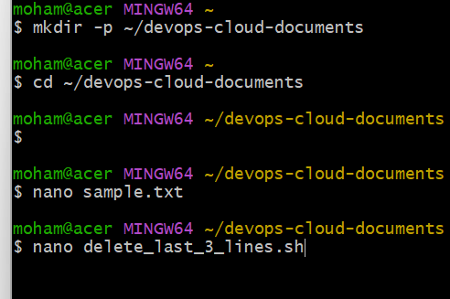

Step 4: Give execute permission
chmod +x delete_last_3_lines.sh

Step 5: Execute the script
./delete_last_3_lines.sh sample.txt
Expected output:
Last 3 lines deleted successfully.

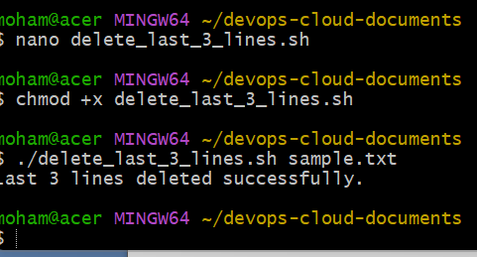

Step 6: Verify the result
cat sample.txt
Expected output:
Line 1
Line 2
Line 3
The script modifies the original file. Make a backup first if you need to preserve the original content.
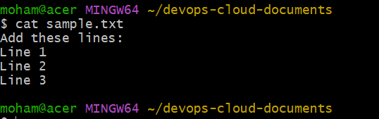

Task 2: Monitor CPU usage and send an email if it exceeds 80%

Step 1: Install the required packages
For Amazon Linux 2023:
sudo dnf install -y sysstat mailx
For Ubuntu:
sudo apt update
sudo apt install -y sysstat mailutils
An email service or SMTP relay must also be configured for notifications to reach your inbox.
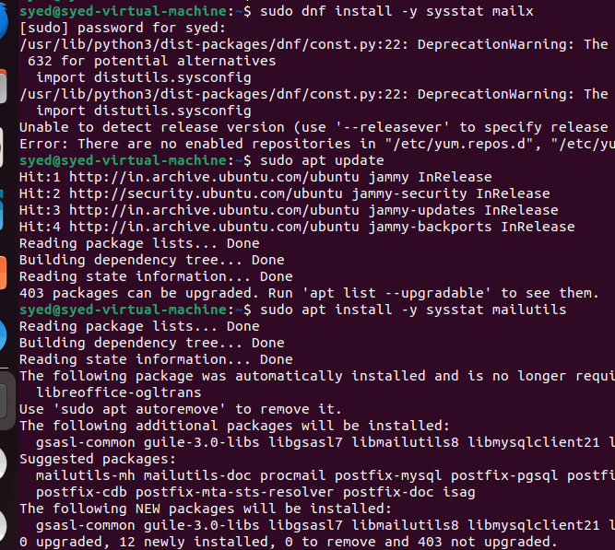

Step 2: Check CPU usage
mpstat 1 1
Look for %idle in the output. CPU usage is approximately 100 - %idle. 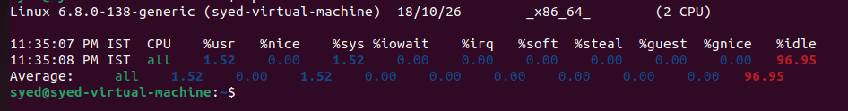

Step 3: Create the CPU monitoring script
nano cpu_monitor.sh
Paste this code:
#!/bin/bash

THRESHOLD=80
EMAIL_TO="syedi7254@gmail.com"
INTERVAL=60

while true; do
IDLE=$(mpstat 1 1 | awk '/Average:/ && $NF ~ /^[0-9.]+$/ {print $NF; exit}')

if [[ -z "$IDLE" ]]; then
echo "Unable to read CPU usage."
sleep "$INTERVAL"
continue
fi

CPU=$(awk -v idle="$IDLE" 'BEGIN {printf "%.0f", 100-idle}')

echo "$(date): CPU usage is ${CPU}%"

if (( CPU > THRESHOLD )); then
SUBJECT="CPU Alert: Usage above 80%"
BODY="CPU usage is ${CPU}% on $(hostname) at $(date)."

printf '%s\n' "$BODY" | mail -s "$SUBJECT" "$EMAIL_TO"

echo "Email alert submitted."
fi

sleep "$INTERVAL"
done
Replace your-email@example.com with your actual email address.
Save and exit.

Step 4: Give execute permission
chmod +x cpu_monitor.sh

Step 5: Test email delivery
echo "Test email from EC2" | mail -s "Email Test" your-email@example.com

Check your inbox and spam folder. If the email does not arrive, configure and troubleshoot the server's mail service or SMTP relay.
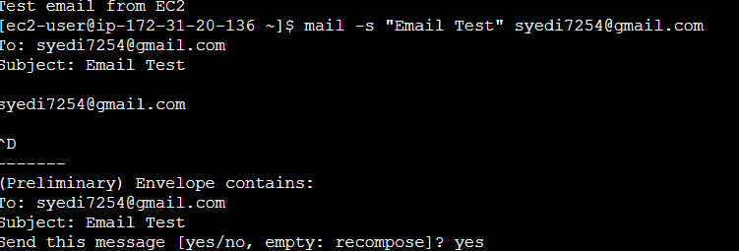

Step 6: Run the CPU monitoring script
./cpu_monitor.sh
The script checks CPU usage approximately every 60 seconds.
Example output:
Sun Oct 18 20:00:00 IST 2026: CPU usage is 45%
Sun Oct 18 20:01:00 IST 2026: CPU usage is 85%
Email alert submitted.
Press Ctrl+C to stop the script.
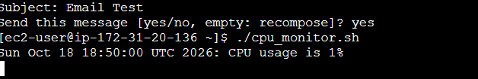

Step 7: Run the script in the background (optional)
nohup ./cpu_monitor.sh > cpu_monitor.log 2>&1 &
View the logs:
tail -f cpu_monitor.log
This basic script sends repeated emails while CPU usage remains above 80%. For production use, add an alert cooldown to avoid too many emails.
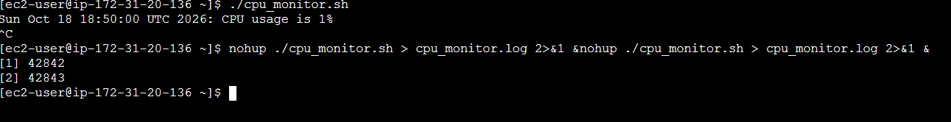

Final verification
Run these commands from your devops-cloud-documents directory:
ls -l
./delete_last_3_lines.sh sample.txt
./cpu_monitor.sh

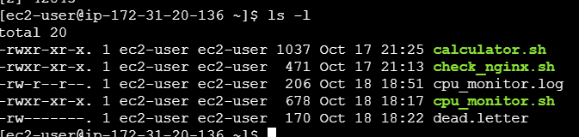
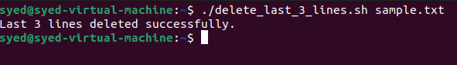
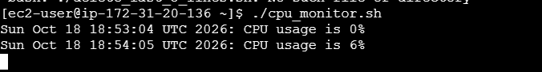
Important: The first script can be tested immediately. The second requires sysstat and a configured email service. I have provided the scripts and execution steps, but I cannot directly execute them in your external devops-cloud-documents channel or AWS account from this chat.

